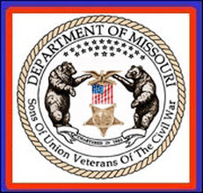
SONS OF UNION VETERANS OF THE CIVIL WAR
DEPARTMENT OF MISSOURI
www.suvcwmo.org

Dale Crandell, PDC
Commander
commander@suvcwmo.org

DEPARTMENT ORDER NO. 2
Series 2019-2020
17 June 2019

Passing of Brother Robert Dean Hammack

With sorrow, the Department of Missouri, Sons of Union Veterans of the Civil War reports the passing of Brother Robert (Bob) Dean Hammack on 13 June 2019. Brother Bob was a life member of the Lt. Col. J. Felix St. James Camp #326. He faithfully served for many years as both Department and Camp Eagle Scout Coordinator

In memory of Brother Robert Hammack, the Department’s Charter and website shall be draped, all Camp Charters and websites shall be draped, and all brothers shall attach a black mourning ribbon to their membership badge. Following the Department’s mourning policy, this Order shall remain in effect for fourteen days from this date.

Ordered this 17th Day of June, 2019, Attest:

Dale Crandell, PDC Edward Krieser, PCinC
Commander Secretary
Department of Missouri Department of Missouri
Sons of Union Veterans of the Civil War Sons of Union Veterans of the Civil War

